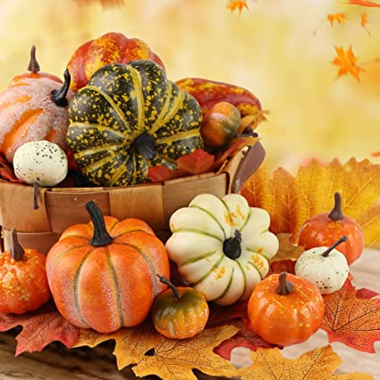 2022
Hi Everyone,
Hope all of you are enjoying these cooler temperatures! We, at Life of Pretty, prefer the warmer weather, but know there are so many out there who need our Warm Wishes, so here we go again.
What do the holidays mean to you? Yes, it’s that time of year where many of us and enjoying time with family and friends, great food, holiday decorations, shopping for loved ones, all the endearing and stressful preparations for the holidays. Well, for 1000’s of men women and children, it might mean holidays in the hospital, a country far away from those they love, or somewhere, on the cold streets with or without their families.
So, as many of you know, at LifeofPretty , we have created Cards for Our Vets, to bring our veterans some much needed sunshine and show our appreciation, mainly to those veterans at Coatesville VA Medical Center. With much anticipation, Cards for Our Vets is asking you to help with our collection of hand-made cards, pictures and notes for those dedicated men and women past and present, who keep us safe.
For another year, we were hoping to continue that awesome altruistic spirit you have all provided in previous years. We will also be collecting items for those in need in Chester and Montgomery Counties. Gloves, hats, socks, sweatshirts, toilet paper, paper towels. The shelters relayed that there is a need for things like dish soap, laundry detergent, hand soap, and blankets. If there are some items that you no longer use, in good shape, please think about donating. I am sure many will be truly grateful. So, thank you in advance!
While we are all making plans for whatever holiday we celebrate, please take time to think about the countless men, women and children who are trying to figure out where to get warm clothes, food, and shelter for the cold weather to come, and the devoted veterans and military personnel.
There will be collection boxes in various locations. This time we will be visiting our veterans and others in need right before Christmas. Please help us show some love and thanks to so many, that they are never forgotten, and help them stay warm this winter. Collection day will be December 21st. Feel free to contact me either by email jmckiernanclarke738@gmail.com or phone @ 484-688-6128. As always, our veterans love the cards, donations, and anything you provide will truly have an impact. Happy Holidays! Warm Winter Wishes!
Best regards and gratitude, Jeannie McKiernan-Clarke, Cards for Vets and Wishes for Warriors
Please forward this to anyone you think might be interested in supporting these collections.

